 [Translated from German to English - www.onlinedoctranslator.com](https://www.onlinedoctranslator.com/en/?utm_source=onlinedoctranslator&utm_medium=docx&utm_campaign=attribution)

u!zubuwsbuniazup.eA

uopluewmioa egospqoai

© by Dr.-Ing. Paul Christiani GmbH & Co. KG

|  |  |  |  |  |  |  |  |  |  |  |  |  |  |  |  |  |  |  |  |  |  |  |  |  |  |  |  |  |
| --- | --- | --- | --- | --- | --- | --- | --- | --- | --- | --- | --- | --- | --- | --- | --- | --- | --- | --- | --- | --- | --- | --- | --- | --- | --- | --- | --- | --- |
| f, 1 i *Z* 1 3 1 4 'I. I a 1 7 I 1 0 | | | | | | | | | | | | | | | | | | | | | | | | | | | | |
| ClassEmmenplan E;;KC1330 17712Z 001 | | | | | | | | | | | | | | | | | | | | | | | | | | | | |
| Radio flonsaxt | | | | | |  |  |  |  | 9wouTacie | List name -MMS+VM -X1 | | | | | | | | | | IawouTecleA |  |  | |  |  | Since/ pound | |
|  |  |  |  | ,--- | Zialbezeachnuno | | onvosuil | Terminal  number | Bridges | ontypsug -e}i2Je9 | | Target designation | | OnTLIJsuld, |  |  |  | |  |  |
|  | | | | | |  |  |  |  |  | +SV - XI | | 11L r | L+ | 0 |  | |  | |  |  |  |  | |  |  | /3.0 | |
|  | | | | | |  |  |  |  |  | +SV-Xi | | 11L- | L- | 3 |  | | -X0 | | 3 |
|  |  | |  |  | /3.0 | |
| cylinder start driving | | | | | |  |  |  |  |
|  | |  | 0.0 | 7 |  | | -Y1. | | 2 |
|  |  | |  |  | /3.1 | |
| Zylander outfohren | | | | | |  |  |  |  |
|  | |  | 0.1 | 0 |  | | -Y2 | | 7 |
|  |  | |  |  | /3 2 | |
| Race(' ve | | | | | |  |  |  |  |
|  | |  | 0. 2 | 0 |  | |  | |  |
|  |  | |  |  | /3.3 | |
|  | | | | | |  |  |  |  |  |  | |  | 0.33 |  |  | |  | |  |  |  |  | |  |  | /3.4 | |
|  | | | | | |  |  |  |  |
|  | |  | O. 4 | 3 |  | |  | |  |  |  |  | |  |  | /3.5 | |
| ..- | | | | | |  |  |  |  |
|  | |  | 0.5 | D |  | |  | |  |
|  |  | |  |  | /3 6 | |
| - | | | | | |  |  |  |  |
|  | |  | 0.60 |  |  | |  | |  |
|  |  | |  |  | /3.7 | |
| - | | | | | |  |  |  |  |
|  | |  | 0.7 | ID |  | |  | |  |
|  |  | |  |  | 13.8 | |
|  | | | | | |  |  |  |  |  |  | |  |  |  |  | |  | |  |  |  |  | |  |  |  | |
|  | | | | | |  |  |  |  |
|  | |  |  |  |  | |  | |  |
|  |  | |  |  |  | |
|  | | | | | |  |  |  |  |
|  | |  |  |  |  | |  | |  |
|  |  | |  |  |  | |
|  | | | | | |  |  |  |  |
|  | |  |  |  |  | |  | |  |
|  |  | |  |  |  | |
|  | | | | | |  |  |  |  |
|  | |  |  |  |  | |  | |  |
|  |  | |  |  |  | |
|  | | | | | |  |  |  |  |  |  | |  |  |  |  | |  | |  |  |  |  | |  |  |  | |
|  | | | | | |  |  |  |  |
|  | |  |  |  |  | |  | |  |
|  |  | |  |  |  | |
|  | | | | | |  |  |  |  |  |  | |  |  |  |  | |  | |  |  |  |  | |  |  |  | |
|  | | | | | |  |  |  |  |
|  | |  |  |  |  | |  | |  |  |  |  | |  |  |  | |
|  | | | | | |  |  |  |  |
|  | |  |  |  |  | |  | |  |
|  |  | |  |  |  | |
|  | | | | | |  |  |  |  |  |  | |  |  |  |  | |  | |  |  |  |  | |  |  |  | |
|  | | | | | |  |  |  |  |
|  | |  |  |  |  | |  | |  |
|  |  | |  |  |  | |
|  | | | | | |  |  |  |  |
|  | |  |  |  |  | |  | |  |
|  |  | |  |  |  | |
|  | | | | | |  |  |  |  |
|  | |  |  |  |  | |  | |  |  |  |  | |  |  |  | |
|  | | | | | |  |  |  |  |
|  | |  |  |  |  | |  | |  |
|  |  |  | |  |  |  | |
|  | | | | | |  |  |  |  |  |  | |  |  |  |  | |  | |  |  |  |  | |  |  |  | |
|  | | | | | |  |  |  |  |
|  | |  |  |  |  | |  | |  |
|  |  | |  |  |  | |
|  | | | | | |  |  |  |  |  |  | |  |  |  |  | |  | |  |  |  |  | |  |  |  | |
|  | | | | | |  |  |  |  |
|  | |  |  |  |  | |  | |  |
|  |  | |  |  |  | |
|  | | | | | |  |  |  |  |
|  | |  |  |  |  | |  | |  |
|  |  | |  |  |  | |
|  | | | | | |  |  |  |  |  |  | |  |  |  |  | |  | |  |  |  |  | |  |  |  | |
|  | | | | | |  |  |  |  |
|  | |  |  |  |  | |  | |  |
|  |  | |  |  |  | |
|  | | | | | | | | | | | | | | | | | | | | | | | | | | | | |
|  | |  | and''"' | 05S'o 20" | azzmni lllll**dead for ..- .4. Mettris11.4,** | | | | | | | STRIP/PLUG. -tiNS+VM-X1transfer module Exits | | | | |  | |  | | | | |  | | | | |
|  |  |  | boa, | one | .0 0 F11YM | | | | |
| CHRISTIRNI GmbH & Co. KG | | | | | | |
| V1.0 | | | | | 10-08-2003 | | | | 1 5 |
|  |  |  | Mepr | whether sop zoos |
| 7 01 |
| Order | ❑.IIIM | name | standard |  | OrSgr **lEri.**r | | | | | | | First C. | | | | |

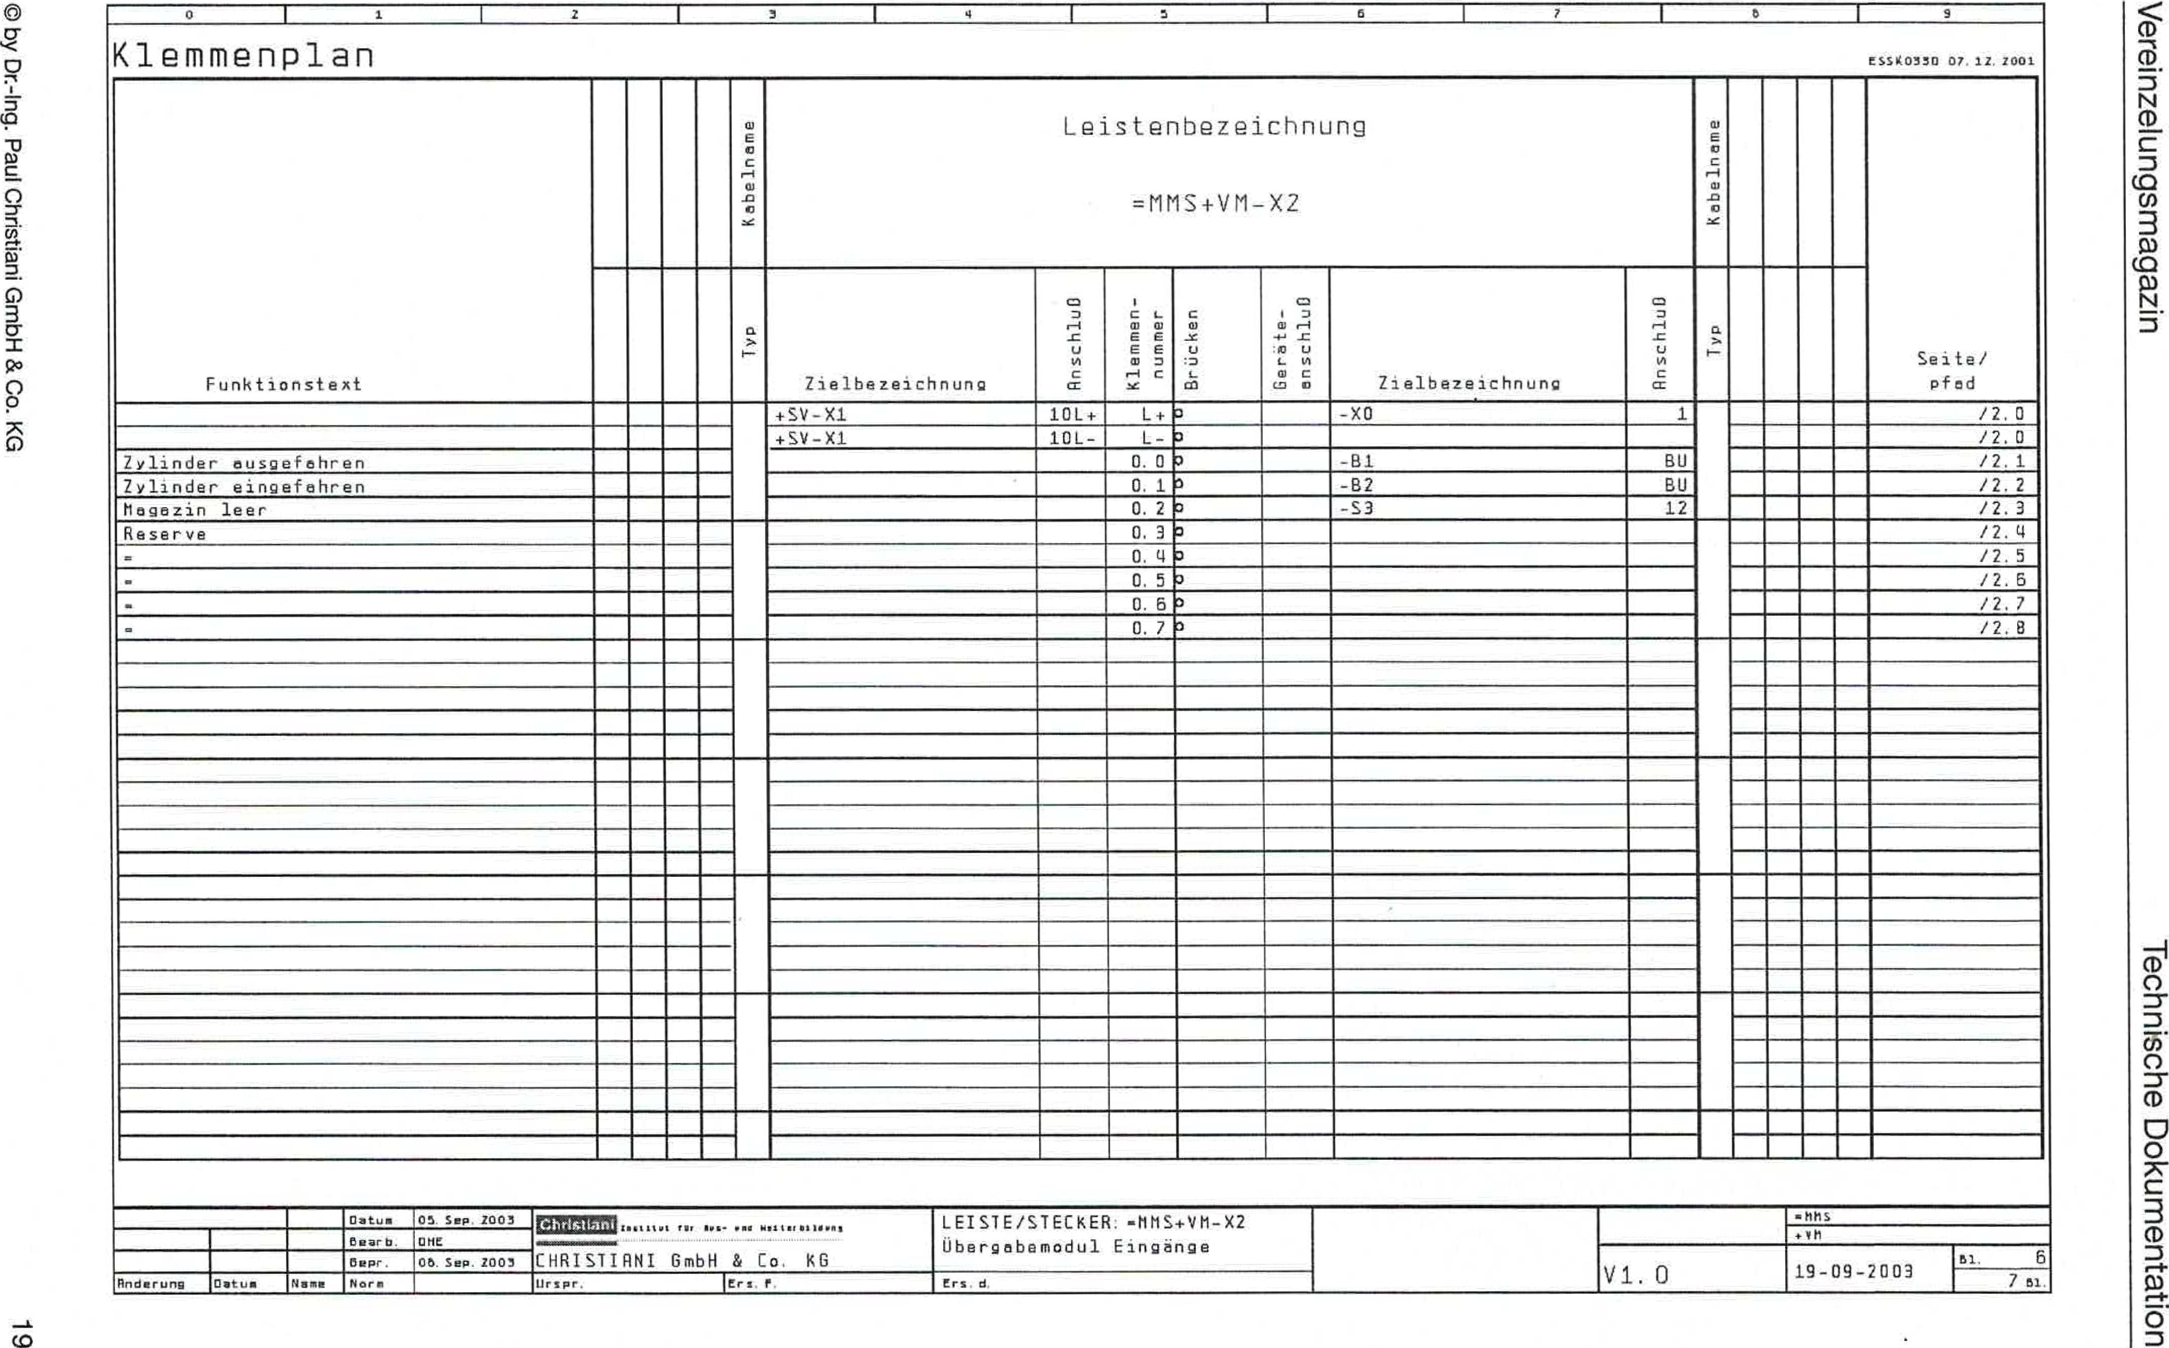

tssi,J,8017lzz001

Learning plan

ONSEP. 2001

13epr

© by Dr.-Ing. Paul Christiani GmbH & Co. KG

uqubuwsbuniezupAaA

uo!luluawmpo aLiospqoai

|  |  |  |  |  |  |  |  |  |  |  |  |  |  |  |  |  |  |  |
| --- | --- | --- | --- | --- | --- | --- | --- | --- | --- | --- | --- | --- | --- | --- | --- | --- | --- | --- |
| Function text |  |  |  |  | IDureuiaqo | Laying designation =MMS+VM-X2 | | | | | | | aulztuiaqc4 |  |  |  |  | se'f— /  pfnd |
|  |  |  |  |  | Target designation | OnT t.los ub | Terminal  *n*summer | ualipn_pg | on-possession | Number designation | Of1TLIJSUH |  |  |  |  |  |
|  |  |  |  |  |  | +SV-X1 |  |  |  |  | -XO | 1 |  |  |  |  |  | /2.0 |
|  |  |  |  |  |  |  |  |  |  |  |  |  |  |  |  | /2.0 |
|  |  |  |  |  |  |  |  |  |  |  |  |  |  |  |  | /2, 1 |
|  |  |  |  |  |  |  |  |  |  |  |  |  |  |  |  | /2.2 |
| empty |  |  |  |  |  |  | 0. 2 |  |  | S3 | 1? |  |  |  |  | /2.3 |
| keserve  Reserve |  |  |  |  |  |  |  | 0.3 |  |  |  |  |  |  |  |  |  | I2.4 |
|  |  |  |  |  |  |  |  |  |  |  |  |  |  |  |  | /7.5 |
|  |  |  |  |  |  |  |  |  |  |  |  |  |  |  |  | /2.5 |
|  |  |  |  |  |  |  |  |  |  |  |  |  |  |  |  | /2, 7 |
|  |  |  |  |  |  |  | 0.7 |  |  |  |  |  |  |  |  | /2.6 |
|  |  | Lu. |  |  |  |  |  |  |  |  |  |  |  |  |  |  |  |  |
|  |  |  |  |  |  |  |  |  |
|  |  |  |  |  |  |  |  |  |  |  |  |  |  |  |  |  |
|  |  |  |  |  |  |  |  |  |  |  |  |  |  |  |  |  |
|  |  |  |  |  |  |  |  |  |  |  |  |  |  |  |  |  |
|  |  |  |  |  |  |  |  |  |  |  |  |  |  |  |  |  |  |  |
|  |  |  |  |  |  |  |  |  |  |  |  |  |  |  |  |  |  |
|  |  |  |  |  |  |  |  |  |  |  |  |  |  |  |
|  |  |  |  |  |  |  |  |  |  |  |  |  |  |  |  |  |
|  |  |  |  |  |  |  |  |  |  |  |  |  |  |  |  |  |
|  |  |  |  |  |  |  |  |  |  |  |  |  |  |  |  |  |  |  |
|  |  |  |  |  |  |  |  |  |  |  |  |  |  |  |  |  |
|  |  |  |  |  |  |  |  |  |  |  |  |  |  |  |  |  |  |
|  |  |  |  |  |  |  |  |  |  |  |  |  |  |  |  |  |
|  |  |  |  |  |  |  |  |  |  |  |  |  |  |  |  |  |  |  |
|  |  |  |  |  |  |  |  |  |  |  |  |  |  |  |  |  |  |  |
|  |  |  |  |  |  |  |  |  |  |  |  |  |  |  |  |  |
|  |  |  |  |  |  |  |  |  |  |  |  |  |  |  |  |  |
|  |  |  |  |  |  |  |  |  |  |  |  |  |  |  |  |  |
|  |  |  |  |  |  |  |  |  |  |  |  |  |  |  |  |  |  |  |
|  |  |  |  |  |  |  |  |  |  |  |  |  |  |  |  |  |  |  |
|  |  |  |  |  |  |  |  |  |  |  |  |  |  |  |  |  |

**EMEncs tttttt . - ."**ws tti e: tint

C▪HRISTIAN' GmbH & Co. KG

* rspr. 'He: f

STRIP/PLUG -hhS+Vh-X2 Obergaba module inputs

First d

.811S

411

19 - 09-2003

Pm:Jump

Oayoum

name

Oatum 105Sep Z003

Oparx.'ONE

standard

vl. 0

No. 6

781

© by Dr.-Ing. Paul Christiani GmbH & Co. KG

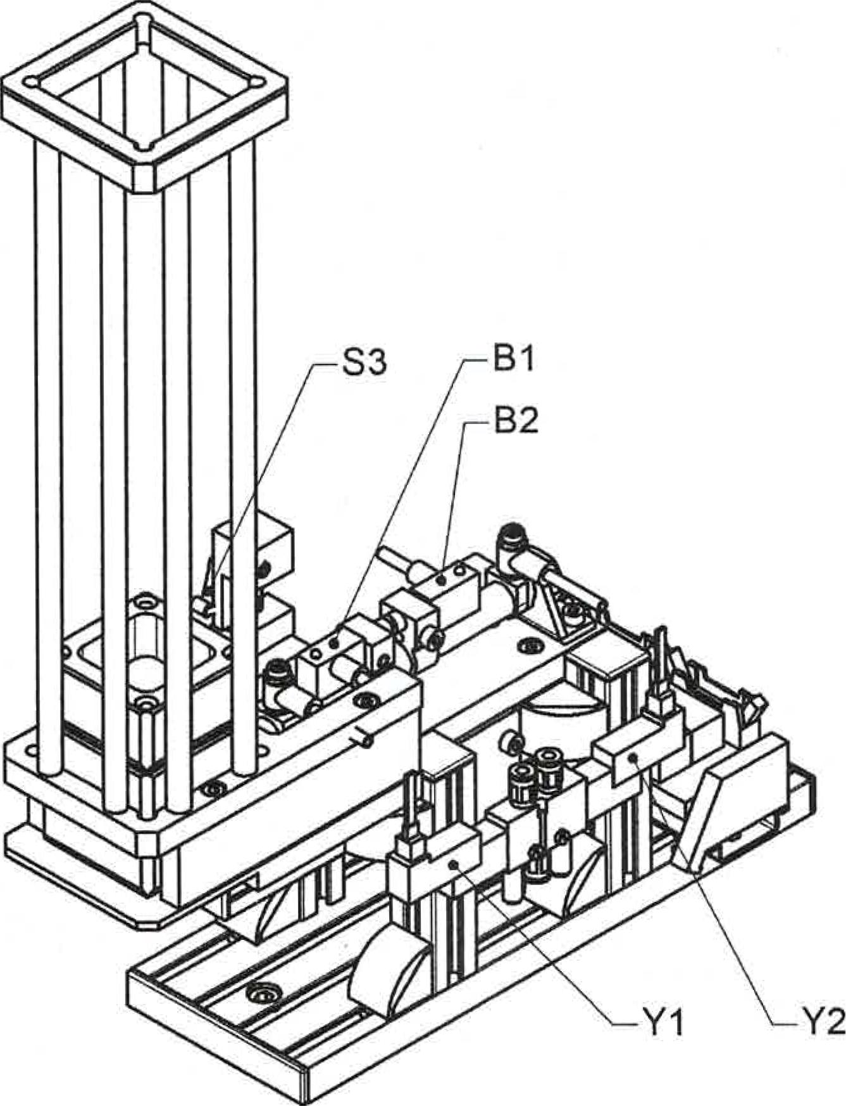

**Technology scheme**

|  |  |
| --- | --- |
| General drawing of the separation magazine drawing 33100058 | 04-07-2003 Blatter 1 |

Christiani

Technical Institute for Training and Further Education

t) Copyright Dr.-Ing. Paul Christiani GmbH 8 Co. KG

**eueicluaLutuanimeidlneituculs**

uvebewsbuniezupAaA

uopluawnoci egospLpei

**4.2 Function plan**

Separation magazine Technical documentation

Step 1

|  |  |  |
| --- | --- | --- |
| Forwarding conditions | **Function plan worksheet**  Steps | Actions |

|  |  |
| --- | --- |
|  | S Retract cylinder |
|  |

Step 4

Cylinder is retracted

Full level ok start signal

Step 2

Cylinder is extended

Step 3

Extend cylinder

— HS I Retract cylinder

Cylinder is retracted

Step 4

© by Dr.-Ing. PaulChristiani GmbH & Co. KG 23

Step 2

**1.3 Total stack list**

Separation magazine Technical documentation

© by Dr.-Ing. Paul Christian' GmbH & Co. KG

7

|  |  |  |  |
| --- | --- | --- | --- |
| **01.00 Carrier kit** | | | |
| **Item No.** | **Number** | **component** | **remark** |
| 01.01 | 1 | Grooved plate 80/14x230 | mechanical processing |
| 01.02 | 4 | Al profile 20x20x85 |  |
| 01.03 | 2 | Cover cap 80x14 black |  |
| 01.04 | 8 | Angle 20x20 NU6 |  |
| 01.05 | 8 | Angle cover cap 20x20 |  |
| 01.06 | 12 | Hammer nut M4 NU6 |  |
| 01.07 | 16 | Cylinder head screw ISO 4762 - M4x8 - 8.8 |  |
| 01.08 | 4 | T-slot nut M4 NU5 steel |  |
| 01.09 | 2 | cylinder head screw**DIN**7984 - M6x16 - 8.8 |  |
| 01.10 | 2 | Hammer nut M6 NU8 |  |
| 01.11 | 1 | AI profile 40120x171 |  |
| 01.12 | 8 | Cover cap 20x20 |  |
| **02.00 Kit insert** | | | |
| 02.01 | 1 | Plate 70/10x225 | mechanical processing |
| 02.02 | 4 | T-slot nut M4 NU6 |  |
| 02.03 | 6 | Cylinder head screw ISO 4762- M4x10 - 8.8 |  |
| 02.04 | 1 | slider | mechanical processing |
| 02.05 | 1 | Pneumatic round cylinder D= 10 stroke= 60 |  |
| 02.06 | 1 | Foot mounting for cylinder D= 10 |  |
| 02.07 | 2 | Clamp holder for cylinder switch d=10 |  |
| 02.08 | 2 | Cylinder switch for cylinder d= 10 |  |
| 02.09 | 2 | PU pipe black D= 4 I= lm |  |
| 02.10 | 2 | Throttle valve M5 exhaust air throttled |  |

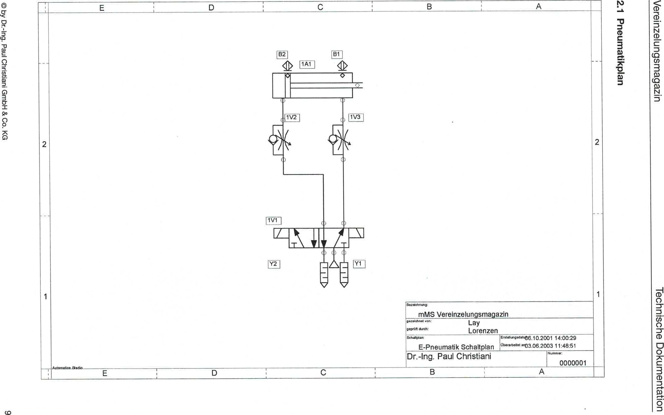

© by Dr-Ing. Paul Christiani GmbH & Co. KG

co

**ueichigewneud**

1.)

u!zebewsbuniezupAaA

uop.ewewmpa agospipai

E D C B **A**

1811

**2**

Vivi I

1

|  |  |  |  |
| --- | --- | --- | --- |
| **Afeett** |  | **Designation2**  mMS separation magazine |  |
| **drawn by Lay**  **geprIAthrough: Lorenzen** |
| **Vision plan**  E-Pneumatics circuit diagram | E.'"ung.1.0,06.10.2001 14:00:29 ab'irm. 50°' 'fl03.06. 2003 11:48:51  **rummer:**  **0000001** |
| **Dr.-Ing. Paul Christiani** |
| **,AJitarnsfinot** | r-  E B  , | |  |

11V31

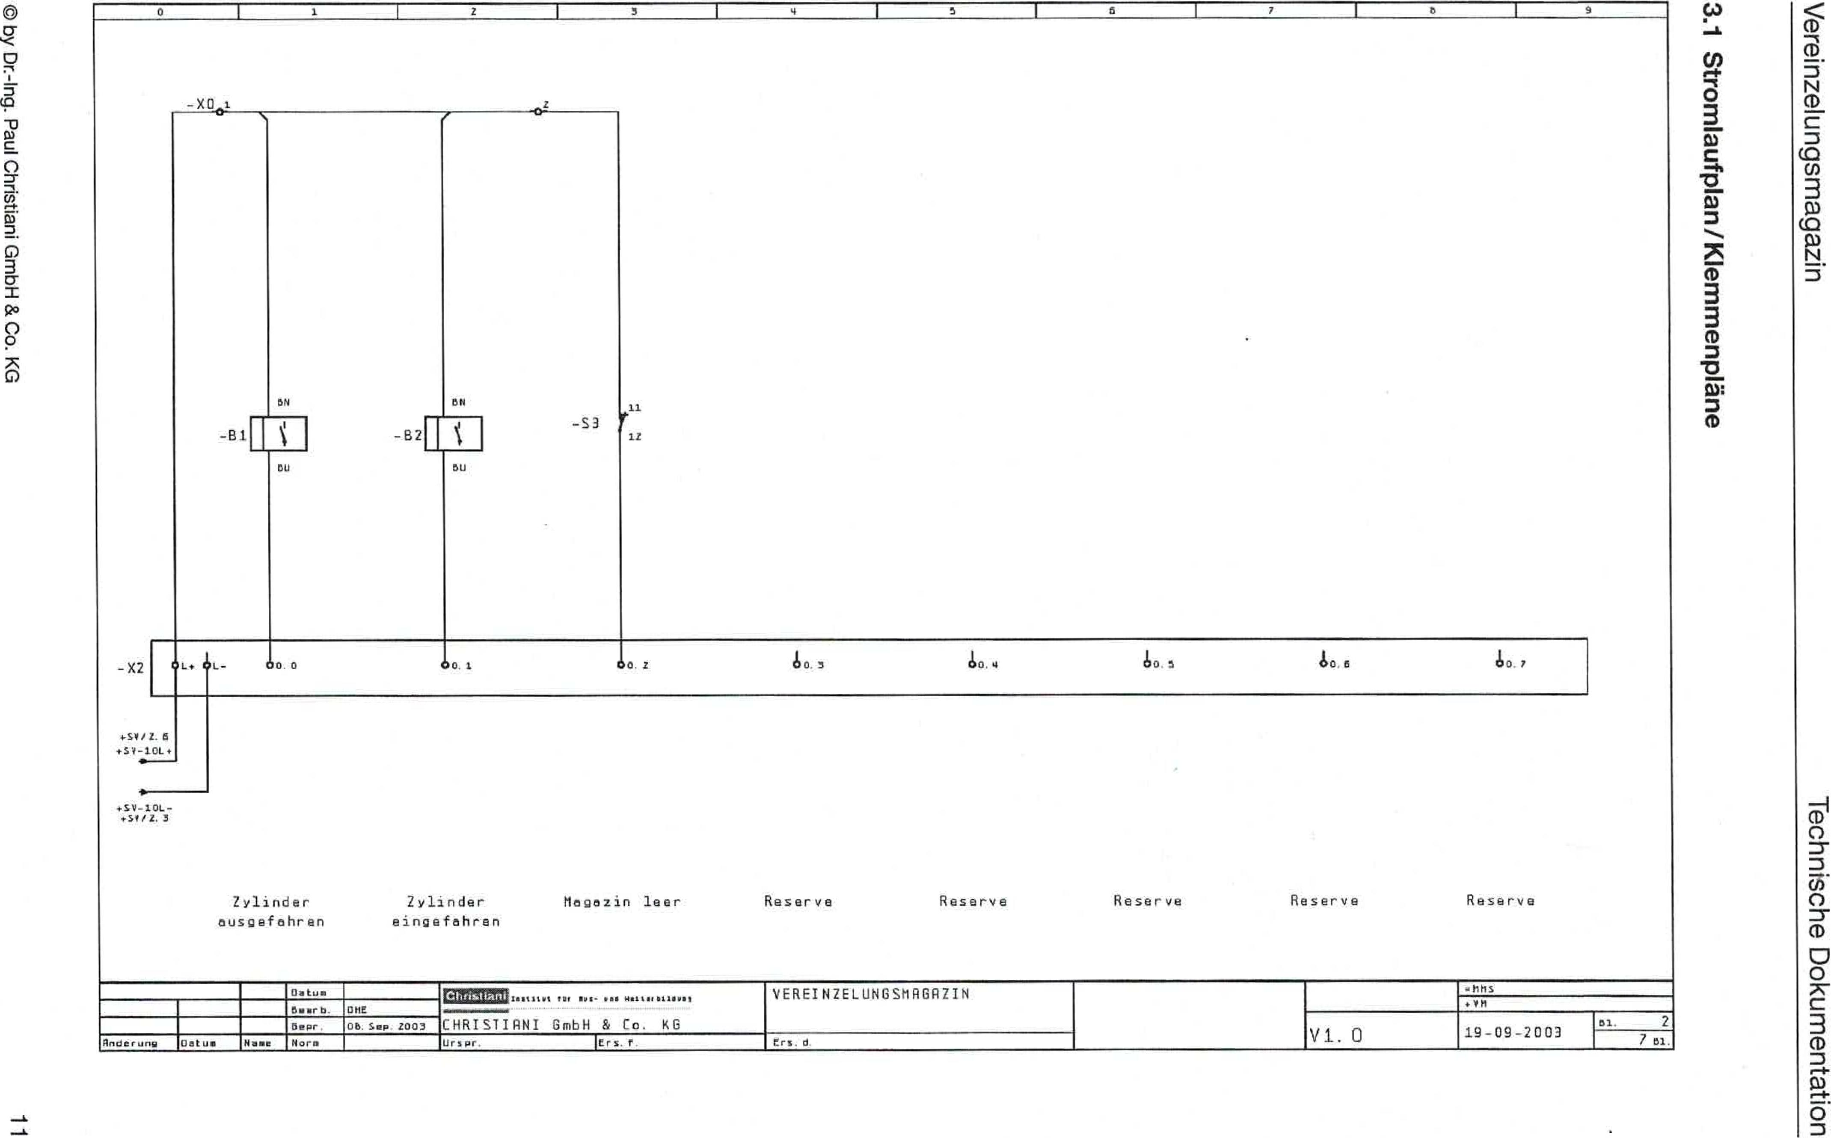

**7**

1 4 1 1 6 1

EN '00'8 Hclw0 !ue!Isplio ined-6ut-J0 Aq 0

**3.1 Circuit diagram/terminal plan**

**ugvbewsbuniezupeA**

**uogeluewmpa egospqoal**

**5**

***-x0_1 _2***

|  |  |  |  |  |  |  |  |  |  |  |  |  |  |
| --- | --- | --- | --- | --- | --- | --- | --- | --- | --- | --- | --- | --- | --- |
| **Ols** | **tll-** | **110.** | **0** | **10L** | **10. I** | **110.** | **3** | **40. 4** | **10,** | **S** | **SO 0** | **10** | **7** |

Magazine empty reserve reserve reserve reserve reserve

2 cylinders extended

Cylinder retracted

**110:=11 ....... according to Mos. owl .1.1 .11.01, sr.**

CHRISIIRNI GmbH & Co. KB

**Ursvir. 1ers.7**

**Date**

**Bow-b.**

**0110**

**Briar**

**Change**

**standard**

**Date**

**Whether.SEP2003**

SINGULATION MRBRZIN

**+5972. +SV-10L,**

•

**Ors.**d.

.114S

**♦99**

101. 2

19-09-2009

751.

V1. 0

-X2

1

**ON**

**ON**

-S3

**BU**

**YOU**

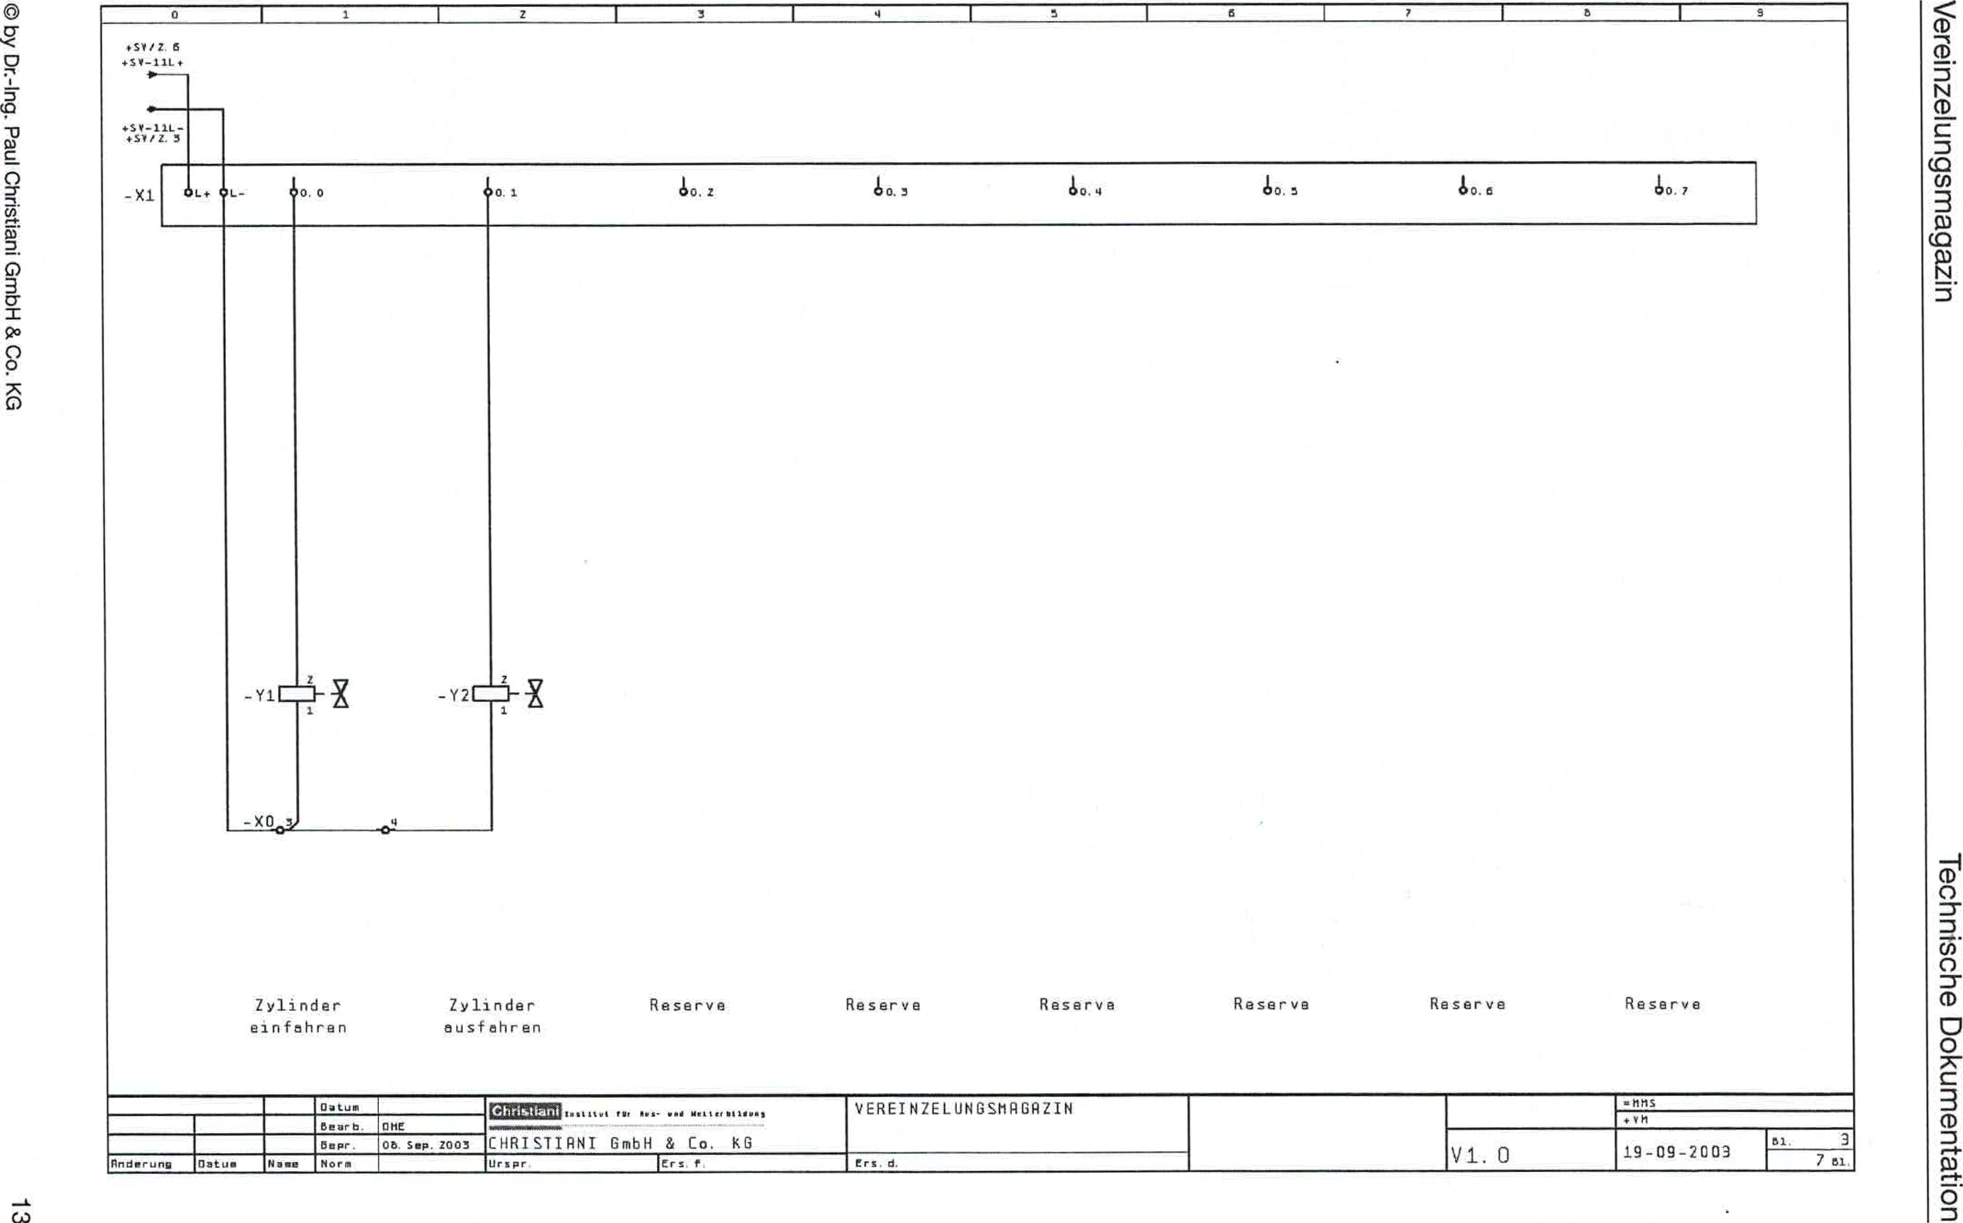

**4**

0

**3**

**5**

Retract cylinder

Extend cylinder

reserve reserve

reserve reserve reserve reserve

© by Dr.-Ing. Paul Christiani GmbH & Co. KG

**u!zubewsbuniezupeA**

**uoq.eluewrnioa egosiugoei**

**+50/7.6 +00-11L+**

**45V-11L-**

**4.5,112.3**

|  |  |  |  |  |  |  |  |  |  |
| --- | --- | --- | --- | --- | --- | --- | --- | --- | --- |
| **IL+ OL.-** |  | **t/. 0** | **10.1** | **b0.2** | **10.3** | **10.4** | **60.3** | **S0.6** | **0.7** |

**Beare**

**Date_**

**lake**

**&&& •1411 Nell te N1111••,**

ASSOCIATION OF AGRICULTURE

=NIS

**Review**

CHRISTIRNI GmbH & Co. KG

**05 Sep. Z003**

vsee0

19-09-2003

**51** 3

7 tbsp

**Cr.. d.**

oatu■

**Ur s pr**

**marriage**

**lFirst**

**standard**

**Black**

-xl

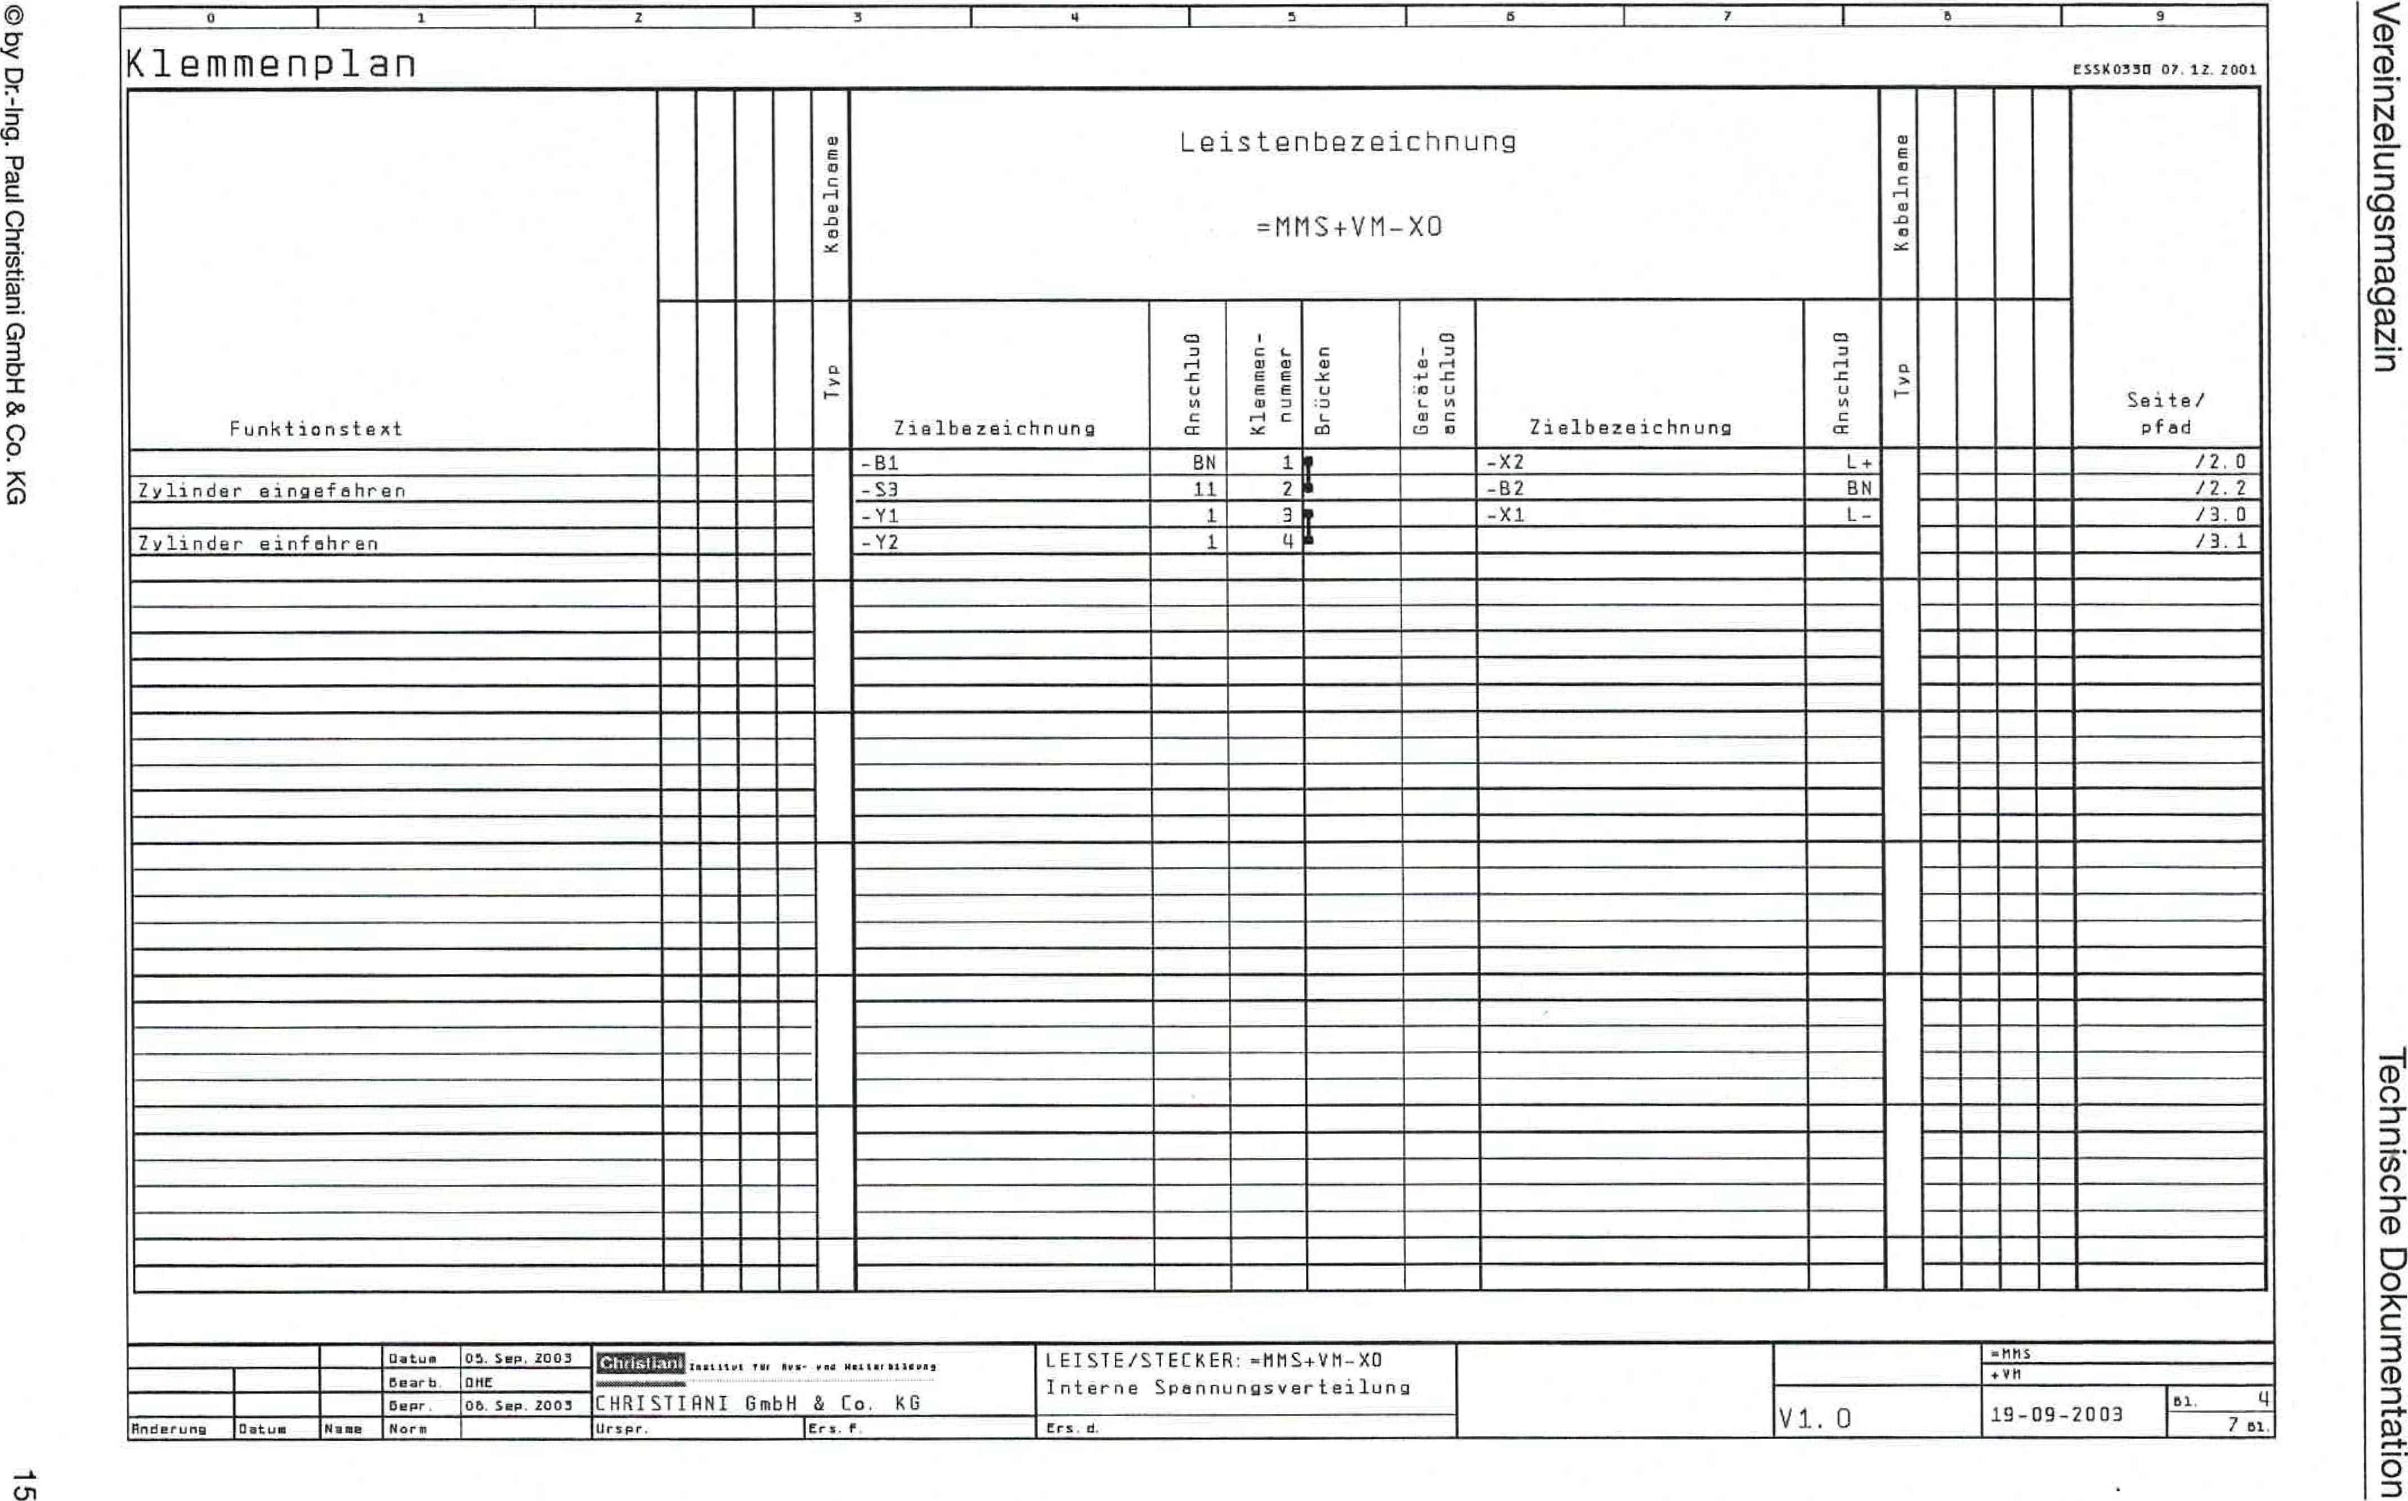

CS7,K0330 07 07 7001

Terminal diagram

01

7of

19-09-2003

© by Dr.-Ing. Paul Christiani GmbH & Co. KG

01

u!zebewsbuniezupAaA

uoq.eluawmpo egospLioei

3

|  |  |  |  |  |  |  |  |  |  |  |  |  |  |  |  |  |  |  |
| --- | --- | --- | --- | --- | --- | --- | --- | --- | --- | --- | --- | --- | --- | --- | --- | --- | --- | --- |
| Function text |  |  |  |  | IatonuTaq | Bar designation  .MMS+VM-X0 | | | | | | | IaUJBUT@gGl |  |  |  |  | somersault/ pfed |
|  |  |  |  |  | Target definition | oniyzsuu | Klernmen-  number | Bridges | Devices-  connection | Target name | pnjyDsuy | dhey |  |  |  |  |
|  |  |  |  |  |  | -B1 | BN | 1/ | |  | -X2 | L-4. |  |  |  |  |  | /2.0 |
| cylinder retracted |  |  |  |  | -S3 | 11 | 7i | |  | -B2 | BN |  |  |  |  | /2.2 |
|  |  |  |  |  | -Y1 | 1 | 3T | |  | -X1 | L- |  |  |  |  | /3.0 |
| cylinder retract |  |  |  |  | -Y2 | 1 | **t1 A** | |  |  |  |  |  |  |  | 13.1 |
|  |  |  |  |  |  |  |  | |  |  |  |  |  |  |  |  |
|  |  |  |  |  |  |  |  |  | |  |  |  |  |  |  |  |  |  |
|  |  |  |  |  |  |  |  | |  |  |  |  |  |  |  |  |
|  |  |  |  |  |  |  |  | |  |  |  |  |  |  |  |  |
|  |  |  |  |  |  |  |  | |  |  |  |  |  |  |  |  |
|  |  |  |  |  |  |  |  | |  |  |  |  |  |  |  |  |
|  |  |  |  |  |  |  |  |  | |  |  |  |  |  |  |  |  |  |
|  |  |  |  |  |  |  |  | |  |  |  |  |  |  |  |  |
|  |  |  |  |  |  |  |  | |  |  |  |  |  |  |  |  |
|  |  |  |  |  |  |  |  | |  |  |  |  |  |  |  |  |
|  |  |  |  |  |  |  |  | |  |  |  |  |  |  |  |  |
|  |  |  |  |  |  |  |  |  | |  |  |  |  |  |  |  |  |  |
|  |  |  |  |  |  |  |  | |  |  |  |  |  |  |  |  |
|  |  |  |  |  |  |  |  | |  |  |  |  |  |  |  |  |
|  |  |  |  |  |  |  |  |  | |  |  |  |  |  |  |  |  |
|  |  |  |  |  |  |  |  | |  |  |  |  |  |  |  |  |
|  |  |  |  |  |  |  |  |  | |  |  |  |  |  |  |  |  |  |
|  |  |  |  |  |  |  |  | |  |  |  |  |  |  |  |  |
|  |  |  |  |  |  |  |  | |  |  |  |  |  |  |  |  |
|  |  |  |  |  |  |  |  |  | |  |  |  |  |  |  |  |  |
|  |  |  |  |  |  |  |  | |  |  |  |  |  |  |  |  |  |
|  |  |  |  |  |  |  |  |  | |  |  |  |  |  |  |  |  |  |
|  |  |  |  |  |  |  |  | |  |  |  |  |  |  |  |  |
|  |  |  |  |  |  |  |  | |  |  |  |  |  |  |  |  |  |
|  |  |  |  |  |  |  |  | |  |  |  |  |  |  |  |  |
|  |  |  |  |  |  |  |  | |  |  |  |  |  |  |  |  |
|  |  |  |  |  |  |  |  |  | |  |  |  |  |  |  |  |  |  |
|  |  |  |  |  |  |  |  | |  |  |  |  |  |  |  |  |

=t•ssi.twl**1.1 My, •elP Nei l•e 133•YRI  
 pow**

CHRISTIRNI GmbH & Co. KG

Ors Pr F

POWER PLUG:=MMS+VM-X0 Internal voltage distribution

trs d,

Li a tu

05 Sep 0003

-0t15.

Snderun9

Oakum

N31.

near b

DePr

standard

0I1E

05SOP.Z003

V1.0

**Christiani**

**Technical Institute for Education and Training**

**mMS training concept**

**Mechatronics/Automation Technology**

**Technical documentation**

**Functional module**

**Separation magazine**

Order No. 64424

0 by ❑r.-Ing. Paul Christiani GmbH & Co. KG

© by Dr.-Ing. Paul Christiani GmbH & Co. KG

|  |  |  |
| --- | --- | --- |
| Separation magazine Technical documentation | | |
| **Table of contents**  **1 mechanics** | |  |
| 1.1 | Functional description | 1 |
| 1.2 | Overall drawing | 3 |
| 1.3 | Complete parts list | 7 |
| **2** | **Pneumatics** |  |
|  | Pneumatic plan | 9 |
| **3** | **Electrics** |  |
| 3.1 | Circuit diagram/terminal plan | 11 |
| **4** | **PLC programming** |  |
| 4.1 | Technology scheme | 21 |
| 4.2 | Functional description | 23 |
| 4.3 | Steps | 25 |
| **5** | **Commissioning instructions** | 29 |

**1.1 Functional description**

**Separation magazine Technical documentation**

© by Dr.-Ing. Paul Christian' GmbH & Co. KG 1

The separating magazine can accommodate up to 10 stacked workpieces. A pneumatic cylinder controlled by a 5/2-way valveWhenever a workpiece is loaded, the bottommost workpiece is ejected from the stack. A limit switch checks the loading status of the magazine.

The functional module is completely built on a mounting platform of size 80 x 230 mm and can be flexibly used individually or together with other­functional assemblies are mounted on an aluminum profile plate.

Two 8-bit transfer connectors are available as transfer modules for connection to a PLC. Three digital PLC inputs and two digital PLC outputs are required. The supply voltage of the function moduleis 24 VDC.

The compressed air connection with approx. 4 bar is made via 4 mm connections.

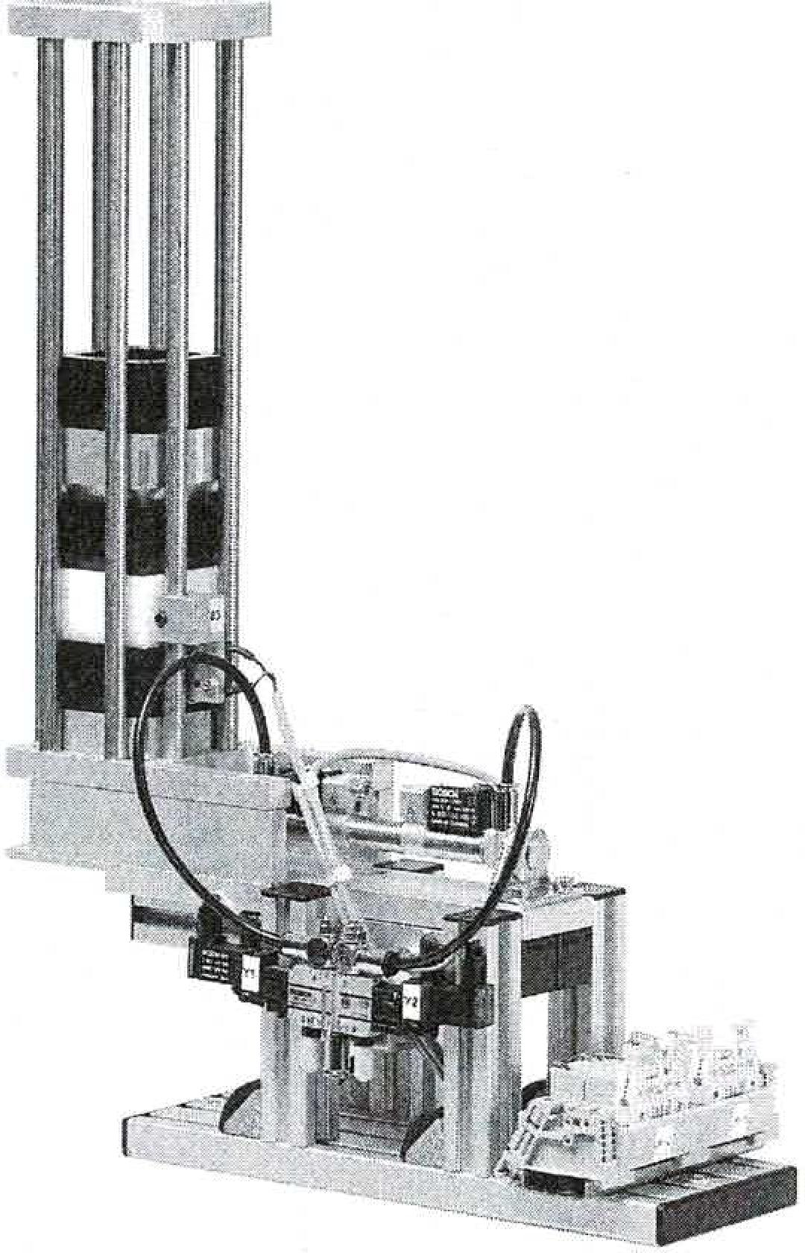

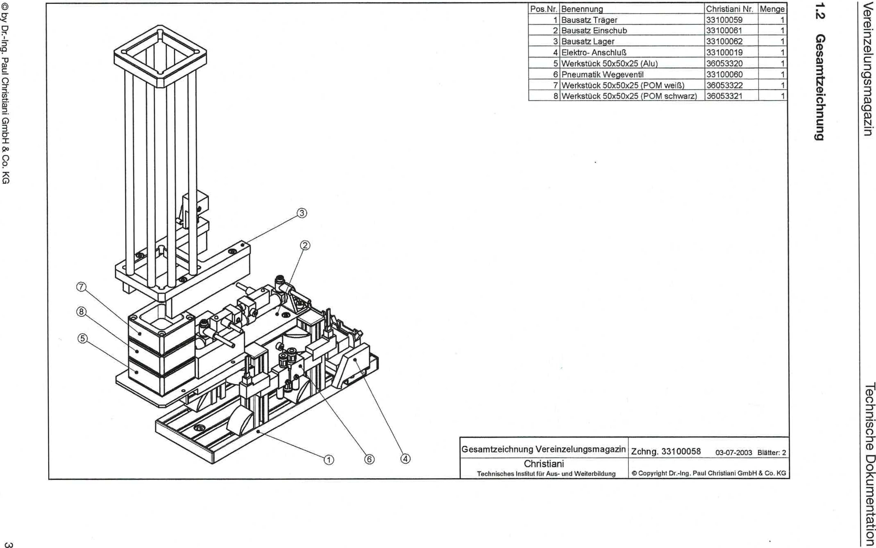

© by Dr.-Ing. Paul Christiani GmbH & Co. KG

CAD

**6unuqopziweseD**

IV

u!zebewsbuniazup,iaA

uo!lewawmpo agospLioal

|  |  |  |  |
| --- | --- | --- | --- |
| Item No. | designation | Christiani No. | Crowd |
| 1 | kitCarrier Kit insert | 33100059  33100061 | 1 1 |
| 2 |
| 3 | Bearing kit | 33100062 | 1 |
| 4 | Electrical connection | 33100019 | 1 |
| 5 | Workpiece 50x50x25 (aluminum) | 36053320 | 1 |
| 6 | Pneumatic directional valve | 33100060 | 1 |
| 7 | Workpiece 50x50x25 (POM wen) | 36053322 | 1 |
| 8 | Workpiece 50x50x25 (POM black) | 36053321 | 1 |

General drawing of the separation magazine

Drawing 33100058 03-07-2003 Blatter: 2

Christiani

Technical Institute for Training and Further Education

0 Copyright Dr.-Ing. Paul Christiani GmbH & Co. KG

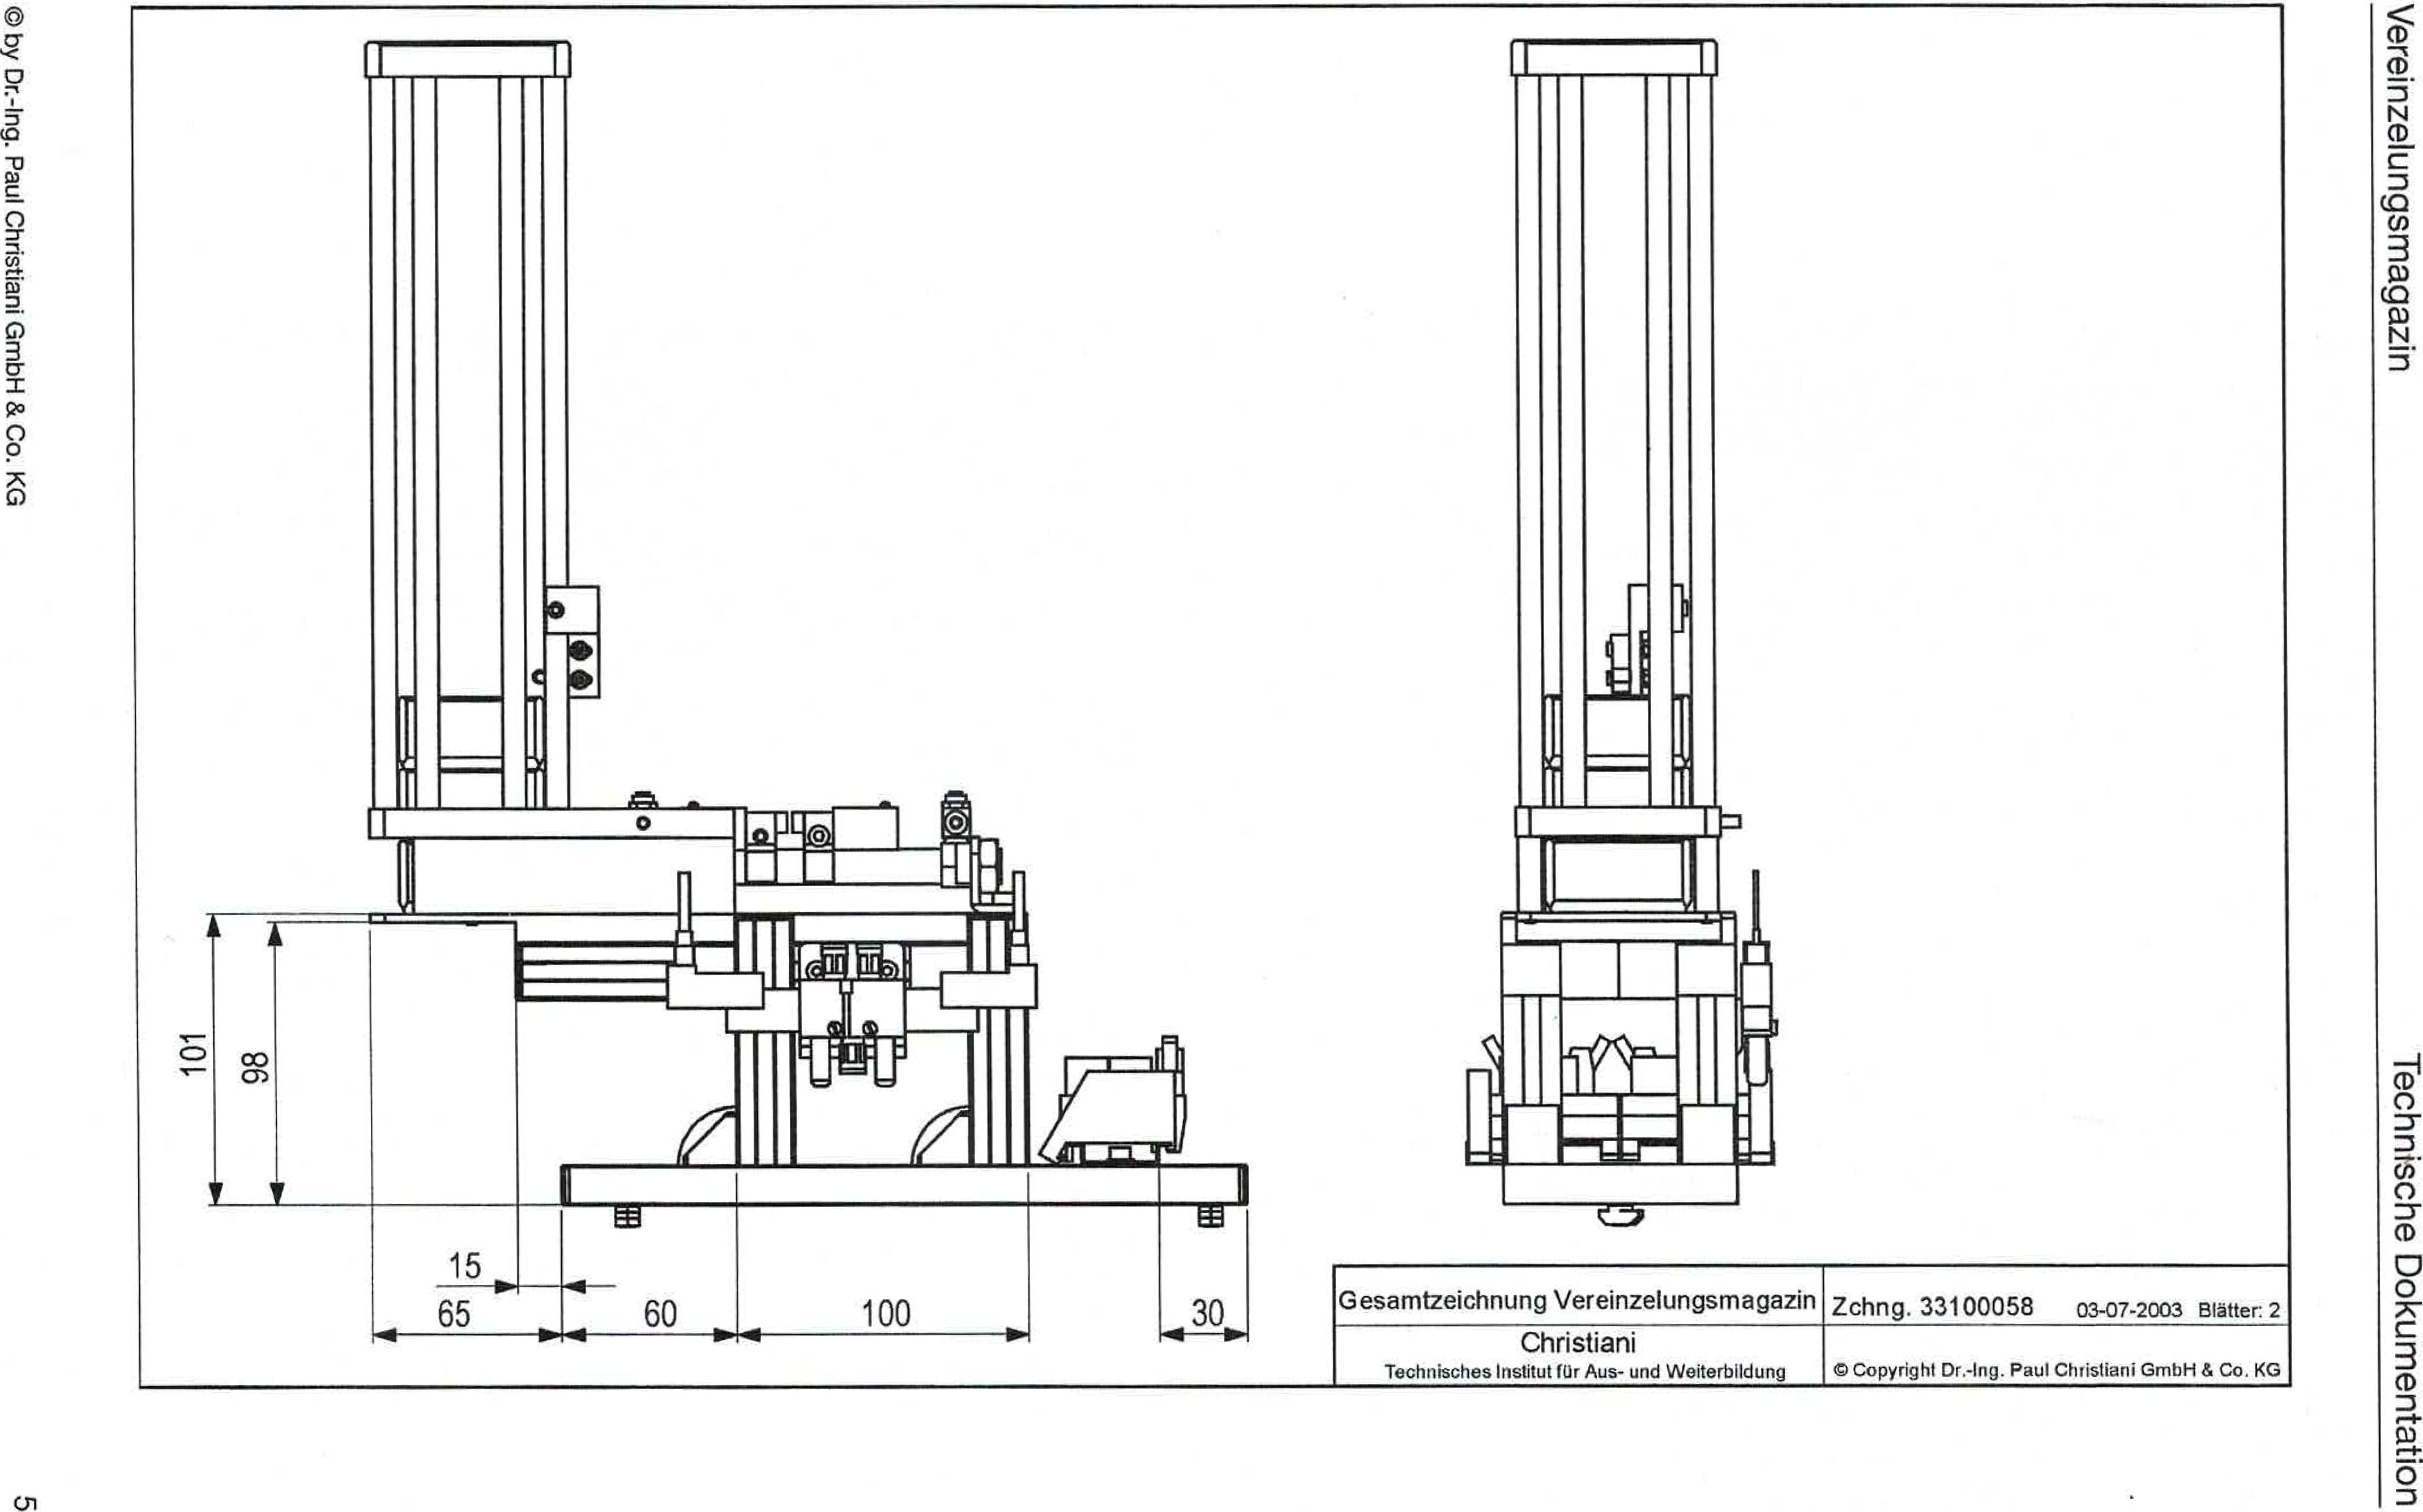

© by Dr.-Ing. Paul Christiani GmbH & Co. KG

01

u!zebewsbuniezupJeA

uop.eluewiThoo eLpsiugoei

03-07-2003 Blatter: 2

General drawing of the distribution magazine drawing 33100058

Christiani

Technical Institute for Financial Education and Training

0 Copyright Dr.-Ing. Paul Chtistiani Gmbh & Co. KG

**OD**

rn